

Asset Practice Answers: Science

**1. Which of these is a food item?**

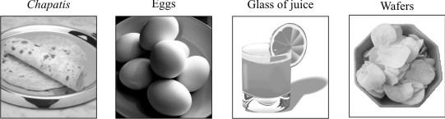

**A.** Only chapatis

**B.** Only chapatis and eggs

**C.** Only chapatis, eggs and wafers

**D. All - chapatis, eggs, glass of juice and wafers**

**2. Mohit wrote two words 'BED' and 'MAN' on a drawing board. He held the board in front of the mirror and looked at the words. They looked different. This is what they looked like.**

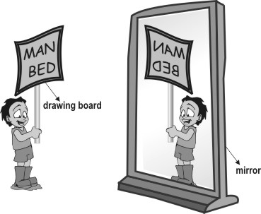

**Which of the following words given below will look the same on both the drawing board and the mirror?**

**A.** HIM

**B.** POT **C. MOM D.** SUN

**3. In the picture shown below, in which of the places (A, B, C or D) is it NIGHT?**

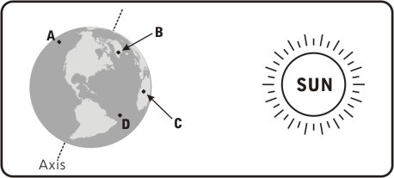

**Correct Answer: A**

**4. Gautum's mother asked him to wash his hands before eating food to remove the germs in his hands.**

**Under which of the following circumstances should he also wash his hands?**

**A.** Cleaning his cycle

**B.** Taking off his shoes

**C.** Watering plants in his garden

**D. Putting medicine on the wound on his knee**

**5. Given below is a picture of India taken from very high up in the sky.**

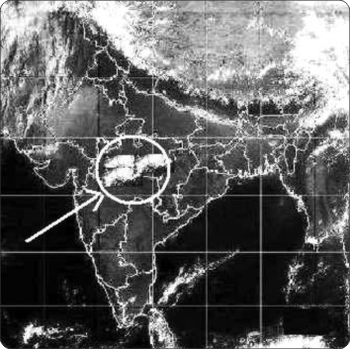

**A.** Air

**B.** Soil

**C. Clouds**

**D.** Ocean

**6. Divya saw tiny things floating in the beam of sunlight that entered the room. What are these tiny things?**

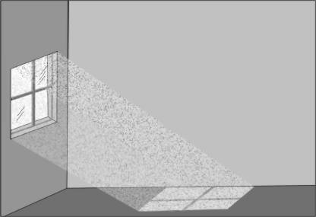

**A.** Particles of air

**B. Particles of dust**

**C.** Particles of water

**D.** Particles of sunlight

**7**. **A support is given for some types of jasmine plants but not for a hibiscus plant. This is because**

**_________.**

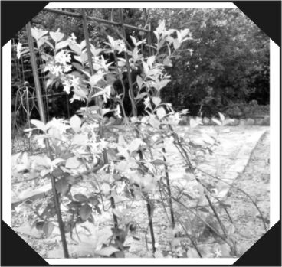

**A.** animals are attracted to some jasmine plants and the support helps to protect it from animals

**B.** only a jasmine plant has flowers because of which it needs a support

**C.** some jasmine flowers smell very good and the support helps to protect them from insects

**D. some jasmine plants have weak stems while hibiscus plants have strong stems**

**8. In India, the Sun rises in the East and sets in the West. In America, in which direction does the Sun rise and set?**

**A. It rises in the East and sets in the West.**

**B.** It rises in the West and sets in the East.

**C.** It both rises and sets in the West.

**D.** It both rises and sets in the East.

**9. Why do we usually not see the Moon during the daytime?**

**A.** Because thick clouds cover it.

**B. Because of the bright sunlight.**

**C.** Because the Moon is there only at night.

**D.** Because the Moon is on the other side of the Earth.

**10.** **In the picture given below, the** **potter is making pots. What material does he use to make pots?**

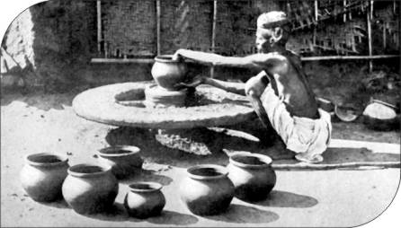

**A. Clay**

**B.** Sand

**C.** Cement

**D.** Bricks

**11. Braille is a special form of writing that blind people can read. Which of these senses do blind people use to read the Braille script?**

**A.** Taste

**B. Touch**

**C.** Smell

**D.** Hearing

**12. Which of the following was invented the last?**

**A.** Calculator

**B.** Typewriter

**C. Laptop**

**D.** Watch



**Science**

1. D: A food item is anything that can be broken down in our body to give us energy and material for growth. Chapatis, eggs, wafers and juice - all give us energy and material for growth. All of them are food. So, option D is correct, not option A.

2. C: You should try this at home. Write the four words given in the options on a paper and check how they appear in the mirror. You will find that the word MOM will look the same. In the other words, the letters will appear reversed.

3. A: The part of the Earth that faces away from the Sun experiences night. In the figure, A is such a part and so it will be night at A.

4. D: Hands are washed before eating because we use our hands to eat and if there are germs, they can enter our body and cause disease. We should also wash our hands before we put medicine on any cut. This is because if the hands are not washed, the germs can again enter the wound and cause some infection. We don't need to wash our hands before taking off our shoes. We should wash hands after we have taken off shoes.

5. C: Do you watch news on TV? You must have seen such a photograph in the weather news. The white part circled shows clouds. They will be present over the part where it is circled. It does not show ocean. Ocean is around the country and not over it.

6. B: The tiny things seen in the beam of sunlight are dust particles. They keep floating everywhere around us in the air. They are so small that they are generally not seen. It is only in bright sunlight and against a dark background that they can be seen. They are not particles of sunlight.

7. D: Have you ever been to a garden that has lots of plants? You will find that there are some small plants which grow straight upwards and there are some plants which require some support to grow. This is because some plants have strong stems which can support the plant. But some plants have weak stems that do not support the plant and so they need something else using which they can climb up.

8. A: In all the parts of the world, the Sun will be seen rising from the East and setting in the West. This does not change from place to place. Do you know why it is like that? It is because the Earth rotates from West to East and so the Sun appears to rise from the East. Just because America is on the western side does not mean that Sun will rise from the West over there.

9. B: Have you ever seen the Moon early in the day? Sometimes the Moon can even be seen in the evening. The reason we cannot see the Moon in the afternoon is not because it is always present on the other side of the Earth. It is because the light of the Sun is so bright that the moon and even other stars that we can clearly see at night, cannot be seen during the day. You can try this - if you have a bulb on your terrace outside, put it on during the afternoon. Stand far away and check how it looks. It won't be easy to see that it is on. That is again because the sunlight is very bright during the afternoon.

10. A: Have you seen a potter making pots? Potters usually use some type of mud to make pots. This mud has to be sticky and cannot be very loose. Sand is very loose and even if you mix it with water, it does not stay in that shape after it has dried. Hence, sand cannot be used to make pots. Clay is a very sticky mud and it is usually used to make pots. Hence, option A is correct.

11. B: People who cannot see with their eyes use their sense of hearing, touch and smell to find out about things around them. Do you know how the Braille script is? It is a sheet of paper or plastic or metal on which there are raised dots in patterns. Each pattern means a certain letter, for example - the shape of A is always the same. People can use their fingers to touch and read this script. Hence, the sense of touch is used to read Braille and not the sense of hearing. Thus, option D is incorrect.

12. C: The typewriter does not work on electricity. Have you seen really old typewriters? They work only by pressing the keys with your hands. They do not need electricity. Watches were also invented much before electricity was discovered. The calculator and laptop were invented after the discovery of electricity. But calculators were invented before big computers and definitely before laptops. Hence, option C is correct - laptops were invented the last.